**E-COMMERCE RESERVATION SYSTEM**

**USE CASE DIAGRAM:**

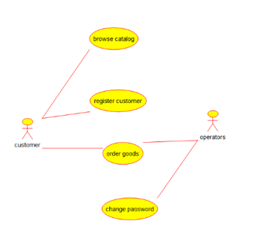

**ACTIVITY DIAGRAM**

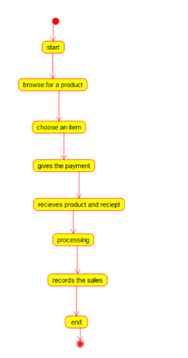

**Class diagram**

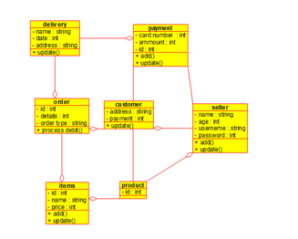

**Sequence diagram**

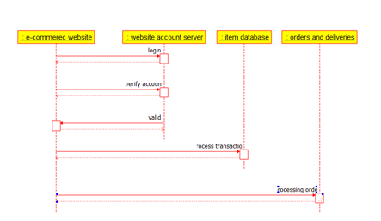

**Package diagram**

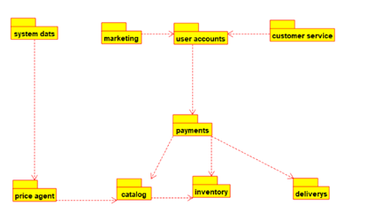

**Deployment diagram**

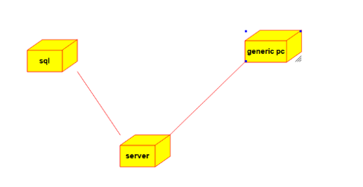

**Component diagram**

